

**Green University of Bangladesh**

**Department of Computer Science and Engineering (CSE)**

**Faculty of Sciences and Engineering**

**Semester: (Fall, Year:2024, B.Sc. in CSE (Day)**

**Lab Report NO #05**

**Course Title: Mobile Application Development**

**Course Code: CSE-402 Section: 213 D-3**

**Lab Experiment Name: Design and Development of a Calculator Application**

**Student Details**

|  |  |  |
| --- | --- | --- |
| **Name** | | **ID** |
| **1.** | Nadib Rana | 213002247 |

**Lab Date : 05.10.2024**

**Submission Date : 12.10.2024**

**Course Teacher’s Name** **: Md. Jahid Tanvir**

|  |
| --- |
| **Lab Report Status**  **Marks: ………………………………… Signature:.....................**  **Comments:.............................................. Date:..............................** |

**1.TITLE OF THE LAB REPORT EXPERIMENT**

Implement the Calculator application in Android device

**2. OBJECTIVES**

-To develop the Calculator application in Android device

-Implement the arithmetic based on the Calculator.

**3. PROCEDURE**

* Create Layout

Design the interface with buttons for numbers (0-9) and operations (+, -, *, /), and a display area .

* Add Listeners

Assign actions to buttons so they can handle user inputs.

* Perform Calculations

Process the input and calculate results based on the selected operation.

* Show Results

Display the output in the display area after performing the calculation.

* Test

Test all functions and fix any errors.

**4. IMPLEMENTATION:**

**ActivityMain.java**

package com.example.claculattor;

import androidx.appcompat.app.AppCompatActivity;

import android.os.Bundle;

import android.view.View;

import android.widget.Button;

import android.widget.EditText;

public class MainActivity extends AppCompatActivity {

Button button0, button1, button2, button3, button4, button5, button6,

button7, button8, button9, buttonadd, buttonSub, buttonDiv,

buttonMul, buttonPoint, buttonReset, buttonEqual;

EditText eT;

float ValueOne, ValueTwo, result;

boolean Addition, Subtract, Multiplication, Division;

@Override

protected void onCreate(Bundle savedInstanceState) {

super.onCreate(savedInstanceState);

setContentView(R.layout.activity_main);

// Referencing

button0 = findViewById(R.id.btnZero);

button1 = findViewById(R.id.btnOne);

button2 = findViewById(R.id.btnTwo);

button3 = findViewById(R.id.btnThree);

button4 = findViewById(R.id.btnFour);

button5 = findViewById(R.id.btnFive);

button6 = findViewById(R.id.btnSix);

button7 = findViewById(R.id.btnSeven);

button8 = findViewById(R.id.btnEight);

button9 = findViewById(R.id.btnNine);

buttonPoint = findViewById(R.id.btnPoint);

buttonadd = findViewById(R.id.btnadd);

buttonSub = findViewById(R.id.btnSub);

buttonMul = findViewById(R.id.btnMul);

buttonDiv = findViewById(R.id.btnDiv);

buttonReset = findViewById(R.id.btnReset);

buttonEqual = findViewById(R.id.btnEqual);

eT = findViewById(R.id.eT);

eT = findViewById(R.id.eT);

eT.setText(&quot;0&quot;);

// Event Listeners

button1.setOnClickListener(new View.OnClickListener() {

@Override

public void onClick(View v) {

eT.setText(eT.getText() + &quot;1&quot;);

}

});

button2.setOnClickListener(new View.OnClickListener() {

@Override

public void onClick(View v) {

eT.setText(eT.getText() + &quot;2&quot;);

}

});

button3.setOnClickListener(new View.OnClickListener() {

@Override

public void onClick(View v) {

eT.setText(eT.getText() + &quot;3&quot;);

}

});

button4.setOnClickListener(new View.OnClickListener() {

@Override

public void onClick(View v) {

eT.setText(eT.getText() + &quot;4&quot;);

}

});

button5.setOnClickListener(new View.OnClickListener() {

@Override

public void onClick(View v) {

eT.setText(eT.getText() + &quot;5&quot;);

}

});

button6.setOnClickListener(new View.OnClickListener() {

@Override

public void onClick(View v) {

eT.setText(eT.getText() + &quot;6&quot;);

}

});

button7.setOnClickListener(new View.OnClickListener() {

@Override

public void onClick(View v) {

eT.setText(eT.getText() + &quot;7&quot;);

}

});

button8.setOnClickListener(new View.OnClickListener() {

@Override

public void onClick(View v) {

eT.setText(eT.getText() + &quot;8&quot;);

}

});

button9.setOnClickListener(new View.OnClickListener() {

@Override

public void onClick(View v) {

eT.setText(eT.getText() + &quot;9&quot;);

}

});

button0.setOnClickListener(new View.OnClickListener() {

@Override

public void onClick(View v) {

eT.setText(eT.getText() + &quot;0&quot;);

}

});

buttonReset.setOnClickListener(new View.OnClickListener() {

@Override

public void onClick(View v) {

eT.setText(&quot;&quot;);

}

});

buttonPoint.setOnClickListener(new View.OnClickListener() {

@Override

public void onClick(View v) {

eT.setText(eT.getText() + &quot;.&quot;);

}

});

buttonadd.setOnClickListener(new View.OnClickListener() {

@Override

public void onClick(View v) {

ValueOne = Float.parseFloat(eT.getText().toString());

Addition = true;

eT.setText(null);

}

});

buttonSub.setOnClickListener(new View.OnClickListener() {

@Override

public void onClick(View v) {

ValueOne = Float.parseFloat(eT.getText().toString());

Subtract = true;

eT.setText(null);

}

});

buttonMul.setOnClickListener(new View.OnClickListener() {

@Override

public void onClick(View v) {

ValueOne = Float.parseFloat(eT.getText().toString());

Multiplication = true;

eT.setText(null);

}

});

buttonDiv.setOnClickListener(new View.OnClickListener() {

@Override

public void onClick(View v) {

ValueOne = Float.parseFloat(eT.getText().toString());

Division = true;

eT.setText(null);

}

});

buttonEqual.setOnClickListener(new View.OnClickListener() {

@Override

public void onClick(View v) {

ValueTwo = Float.parseFloat(eT.getText().toString());

if (Addition) {

result = ValueOne + ValueTwo;

eT.setText(String.valueOf(result));

Addition = false;

}

if (Subtract) {

result = ValueOne - ValueTwo;

eT.setText(String.valueOf(result));

Subtract = false;

}

if (Multiplication) {

result = ValueOne * ValueTwo;

eT.setText(String.valueOf(result));

Multiplication = false;

}

if (Division) {

result = ValueOne / ValueTwo;

eT.setText(String.valueOf(result));

Division = false;

}}});}}

**ActivityMain.XML**

&lt;?xml version=&quot;1.0&quot; encoding=&quot;utf-8&quot;?&gt;

&lt;LinearLayout

xmlns:android=&quot;http://schemas.android.com/apk/res/android&quot;

android:layout_width=&quot;match_parent&quot;

android:layout_height=&quot;match_parent&quot;

android:orientation=&quot;vertical&quot;

android:padding=&quot;16dp&quot;&gt;

&lt;EditText

android:id=&quot;@+id/eT&quot;

android:layout_width=&quot;match_parent&quot;

android:layout_height=&quot;wrap_content&quot;

android:inputType=&quot;none&quot;

android:focusable=&quot;false&quot;

android:textSize=&quot;24sp&quot;

android:padding=&quot;16dp&quot;

android:background=&quot;@android:color/transparent&quot;

android:hint=&quot;0&quot;

android:gravity=&quot;end&quot;/&gt;

&lt;GridLayout

android:layout_width=&quot;match_parent&quot;

android:layout_height=&quot;0dp&quot;

android:layout_weight=&quot;1&quot;

android:columnCount=&quot;4&quot;

android:rowCount=&quot;5&quot;

android:padding=&quot;8dp&quot;&gt;

&lt;Button

android:id=&quot;@+id/btnZero&quot;

android:layout_width=&quot;0dp&quot;

android:layout_height=&quot;wrap_content&quot;

android:layout_columnWeight=&quot;1&quot;

android:text=&quot;0&quot;

android:textSize=&quot;18sp&quot;/&gt;

&lt;Button

android:id=&quot;@+id/btnOne&quot;

android:layout_width=&quot;0dp&quot;

android:layout_height=&quot;wrap_content&quot;

android:layout_columnWeight=&quot;1&quot;

android:text=&quot;1&quot;

android:textSize=&quot;18sp&quot;/&gt;

&lt;Button

android:id=&quot;@+id/btnTwo&quot;

android:layout_width=&quot;0dp&quot;

android:layout_height=&quot;wrap_content&quot;

android:layout_columnWeight=&quot;1&quot;

android:text=&quot;2&quot;

android:textSize=&quot;18sp&quot;/&gt;

&lt;Button

android:id=&quot;@+id/btnThree&quot;

android:layout_width=&quot;0dp&quot;

android:layout_height=&quot;wrap_content&quot;

android:layout_columnWeight=&quot;1&quot;

android:text=&quot;3&quot;

android:textSize=&quot;18sp&quot;/&gt;

&lt;Button

android:id=&quot;@+id/btnFour&quot;

android:layout_width=&quot;0dp&quot;

android:layout_height=&quot;wrap_content&quot;

android:layout_columnWeight=&quot;1&quot;

android:text=&quot;4&quot;

android:textSize=&quot;18sp&quot;/&gt;

&lt;Button

android:id=&quot;@+id/btnFive&quot;

android:layout_width=&quot;0dp&quot;

android:layout_height=&quot;wrap_content&quot;

android:layout_columnWeight=&quot;1&quot;

android:text=&quot;5&quot;

android:textSize=&quot;18sp&quot;/&gt;

&lt;Button

android:id=&quot;@+id/btnSix&quot;

android:layout_width=&quot;0dp&quot;

android:layout_height=&quot;wrap_content&quot;

android:layout_columnWeight=&quot;1&quot;

android:text=&quot;6&quot;

android:textSize=&quot;18sp&quot;/&gt;

&lt;Button

android:id=&quot;@+id/btnSeven&quot;

android:layout_width=&quot;0dp&quot;

android:layout_height=&quot;wrap_content&quot;

android:layout_columnWeight=&quot;1&quot;

android:text=&quot;7&quot;

android:textSize=&quot;18sp&quot;/&gt;

&lt;Button

android:id=&quot;@+id/btnEight&quot;

android:layout_width=&quot;0dp&quot;

android:layout_height=&quot;wrap_content&quot;

android:layout_columnWeight=&quot;1&quot;

android:text=&quot;8&quot;

android:textSize=&quot;18sp&quot;/&gt;

&lt;Button

android:id=&quot;@+id/btnNine&quot;

android:layout_width=&quot;0dp&quot;

android:layout_height=&quot;wrap_content&quot;

android:layout_columnWeight=&quot;1&quot;

android:text=&quot;9&quot;

android:textSize=&quot;18sp&quot;/&gt;

&lt;Button

android:id=&quot;@+id/btnPoint&quot;

android:layout_width=&quot;0dp&quot;

android:layout_height=&quot;wrap_content&quot;

android:layout_columnWeight=&quot;1&quot;

android:text=&quot;.&quot;

android:textSize=&quot;18sp&quot;/&gt;

&lt;Button

android:id=&quot;@+id/btnadd&quot;

android:layout_width=&quot;0dp&quot;

android:layout_height=&quot;wrap_content&quot;

android:layout_columnWeight=&quot;1&quot;

android:text=&quot;+&quot;

android:textSize=&quot;18sp&quot;/&gt;

&lt;Button

android:id=&quot;@+id/btnSub&quot;

android:layout_width=&quot;0dp&quot;

android:layout_height=&quot;wrap_content&quot;

android:layout_columnWeight=&quot;1&quot;

android:text=&quot;-&quot;

android:textSize=&quot;18sp&quot;/&gt;

&lt;Button

android:id=&quot;@+id/btnMul&quot;

android:layout_width=&quot;0dp&quot;

android:layout_height=&quot;wrap_content&quot;

android:layout_columnWeight=&quot;1&quot;

android:text=&quot;*&quot;

android:textSize=&quot;18sp&quot;/&gt;

&lt;Button

android:id=&quot;@+id/btnDiv&quot;

android:layout_width=&quot;0dp&quot;

android:layout_height=&quot;wrap_content&quot;

android:layout_columnWeight=&quot;1&quot;

android:text=&quot;/&quot;

android:textSize=&quot;18sp&quot;/&gt;

&lt;Button

android:id=&quot;@+id/btnReset&quot;

android:layout_width=&quot;0dp&quot;

android:layout_height=&quot;wrap_content&quot;

android:layout_columnWeight=&quot;1&quot;

android:text=&quot;C&quot;

android:textSize=&quot;18sp&quot;/&gt;

&lt;Button

android:id=&quot;@+id/btnEqual&quot;

android:layout_width=&quot;0dp&quot;

android:layout_height=&quot;wrap_content&quot;

android:layout_columnWeight=&quot;1&quot;

android:text=&quot;=&quot;

android:textSize=&quot;18sp&quot;/&gt;

&lt;/GridLayout&gt;

&lt;/LinearLayout&gt;

**OUTPUT:**

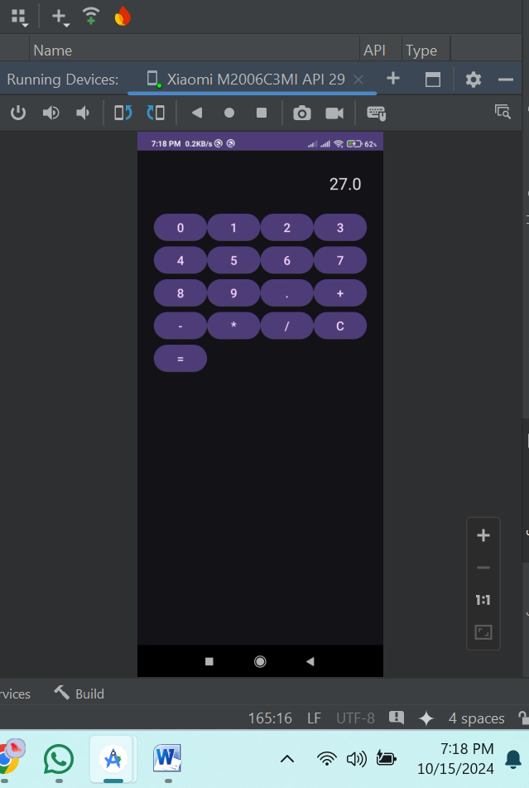

**5. ANALYSIS AND DISCUSSION**

1. **What Went Well**
   * Successfully implemented a functional calculator with a simple interface.
   * Buttons and operations responded accurately to user input.
2. **Challenges**
   * Handling edge cases like division by zero or invalid inputs required extra validation.
   * Ensuring the calculator displayed results correctly without crashing.
3. **Learning Outcomes**
   * Gained hands-on experience in handling user inputs and implementing logic for basic arithmetic operations.
   * Improved understanding of Android UI components and event handling.